Record No: 0680
EDELINE BOTELIER MARJORIE BELLINGHAM SOMERVILLE (‘Tetty’)

4th dau of Bellingham Arthur Somerville (0631) by his wife Margaret Hall Clinch (0632).

Birth: 29 Feb 1892, at Friar’s Hill, Wicklow
Bapt: 2 Sep 1894, at St Audoen’s, Dublin
Marriage: 26 Sep 1929 at Nun’s Cross Church, Killiskey,, Ashford, Co Wicklow
Brig. Ernest Frederick John Hill, D.S.O., M.C. elder son of Ernest George
Hill, by his wife ?
Death: 8 Apr 1973 at The Old House, Herringswell, Suffolk. Bd at Putney Vale Cemetery,
London SW

No issue

Source: Somerville Index

Notes:

Tetty, in all her childhood photographs, and, even as a young adult, looked discontented. She had a complex personality. She was quick to anger, but kind and generous. She had extremely strong opinions and didn’t know the meaning of the word compromise. She had the tenacity of a terrier. She rated all the Somerville men very low indeed; ‘useless’ is the description that comes to mind. She would have blazing rows in public, oblivious to all contrary arguments and totally unmindful of being overheard by others.

Tetty was extremely close to her mother. In correspondence, and in her conversation, even more so, there seemed to be a special relationship. She had a very low opinion of Ireland and the Irish; regarding herself as English. She probably thought of her mother as being stranded in Ireland. Her mother spent WW11 in England, when, even in her 80s, her mother is reputed to have said as she boarded the mail boat “my country needs me”; she spent much of the war with Tetty and John in a rented house in South Kensington.

Yet towards the end of her life, Tetty renewed acquaintance with some of the people of Rathnew who had worked in the house at Clermont, and distributed largesse among them. It was genuine concern and generosity; there was no intention to patronize.

Her fiery temperament was most pronounced after her mother’s death, during the course of her estate administration. Her elder brothers were, in particular, the target of her anger; but no one was free from her arrows; they could land anywhere at any time; Cecil and Vere and, even, Regi who would do anything for a quiet life. However, most, if not all, of what she did showed a high degree of business acumen, and, of course, was done with the best intentions. It was the manner in which she delivered the message that caused most of the family to quake at her approach.

Ultimately, it was Tetty who, single handedly, represented the Somerville family in the negotiations that led to the sale of Clinch & Co to Courage Barclay & Simmons. We all owe her much for keeping the family interest afloat.

While one would hesitate to call Tetty a snob, she was conscious of social status, quick to make suitable contacts, and, especially to retain them and use them when occasion required. She kept a mammoth address book and had a very well developed sense of recall. Of the Somerville daughters of her generation, she was, by far, the smartest and maintained her silver hair and well groomed appearance to the end.
Tetty was 37 when she married John who was then 50. John retired from India a few years later. Sadly, although Tetty talked about it endlessly, particularly in her later years, they never bought a house. Apart from the war years, they lived between 3 hotels in Queensgate: The Imperial, The Queensgate House and, ultimately, The Onslow Court. Many of their wedding presents remained unpacked for the remainder of her life; they and the furniture, pictures and rugs which she had chosen from Clermont were stored in a depository near Victoria Station. Theft and decay brought havoc and subsequent litigation – and – yet more worries to torment her.
After the administration of her mother’s estate was over, Tetty encouraged Regi to research further some of the missing information necessary for him to put in a claim to the Somerville Baronetcy.
Cecil and Regi had done considerable work on this, but it needed Tetty’s tenacity to introduce the subject to the College of Arms through her contact, via John, with Sir Austin Strutt. Suffice it to say here, that she and Regi beavered away for upwards of ten years, before John died, and Regi succumbed to cancer.
When Tetty was at the Onslow Court, she struck up a close friendship with Bob and Sybil Mantell, who were staying in the Hotel while moving house. The friendship continued for many years. Eventually, as they had promised many years previously, when Tetty’s health declined, the Mantells invited her to spend her last days with them at Herringswell where she died in April 1973.
But controversy continued. Tetty had made a new will very shortly before she died; she left a substantial Charitable Trust, and then divided her residue into four equal parts, one for the Rookes, one for the Truells, one for the Somervilles and one for Bob Mantell. One or more members of the Truell family suspected undue influence, presumably from the Mantells; Ray Dewar issued a caveat. The caveat was eventually withdrawn, but it was sometime before Tetty’s previous will came to light with the solicitors she used in her dispute with the depository. In fact, had the final will been set aside, the Rookes and the Truells would not have participated in the residue. Regi was the sole residuary beneficiary.
Tetty, in her later years, had a special place for Regi as the sole surviving Somerville with the prospect of future Somerville issue. She even proposed, after Bunt’s death in 1950, when Kitty had agreed to reduce her interest in Clermont to one half, that Kitty and the family should forego their interest so that it could pass to Regi for future generations; Regi declined – he could never have afforded to run it without the ‘Clermont Fund’ and he was pretty sure that his other sisters would not agree.

Tetty was buried in Putney Vale, with John. Some years previously, she had become concerned the lower part of the cemetery was damp and may be situated over a watercourse. She had a fear of being buried over water – as had her mother (that is why she was buried at Rathnew rather than Wicklow with her husband) – and approached the managers of Putney Vale with a view to exhumation of John’s body and reburial. She was told the coffin would have disintegrated over the years since John’s death, to which she replied ‘Not so, the funeral undertakers were Harrods’. She liked to do things properly.

WBRBS from personal knowledge and conversations with Tetty and Regi.

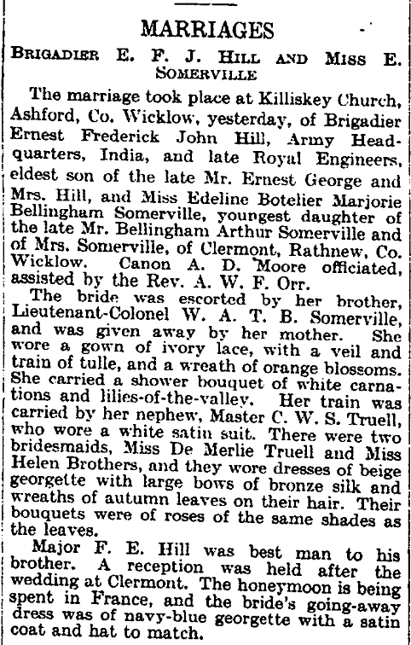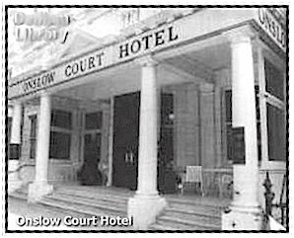
The Times, Friday 27 Sept 1929

The Acid Bath Murders
Neat clusters of condiments ornament the tables in the quiet, tobacco-free dining room of South Kensington's Onslow Court Hotel. There, in a silence broken only by the tinkle of chinaware, an occasional polite belch or a muffled platitude, retired colonels and well-to-do widows dine in respectable isolation without recourse to spirits. One of these was stately Mrs. Olive Henrietta Roberts Durand-Deacon, a widow of 69. She had few close friends at the hotel, but over a period of three years had struck up an acquaintance with a youngish (39) gentleman named John George Haigh, who was, he said, an inventor.

Now it was Mrs. Durand-Deacon's cross that her fingernails were regrettably stubby and she had long nursed an idea for making plastic nails for other women similarly afflicted. One day last February, Mr. Haigh suggested they drive down to a factory he had in Crawley, Sussex. Three days later Haigh reported that Mrs. Durand-Deacon had never met him and never returned to the hotel. Scotland Yard sent out a routine tracer.

Some Human Substance.
Near an old factory in Crawley, detectives soon found some interesting evidence: a piece of red plastic like that on a handbag which the missing widow carried, a ten-gallon carboy, one of several used to store sulphuric acid, and ashlike specimens of what a Home Office pathologist called "the residue of some human substance." Haigh was promptly taken into custody.

British reporters soon found that Scotland Yard was also investigating the disappearance of a wealthy retired official named Donald McSwan, his wife Amy and their son William, Dr. Archibald Henderson, well-to-do proprietor of a doll hospital, and his pretty young wife, Rose.

A Penknife, I Think.
This week dapper John George Haigh himself walked jauntily up to the bench in a Lewes courtroom to plead "not guilty" to the charge of premeditated murder laid against him. He did not, however, deny the killings.

His counsel, Sir David Maxwell Fyfe, read to the court a full statement from his client. In it Haigh explained in detail how he had killed Mrs. Durand-Deacon by shooting her in the head, "then fetched in a drinking glass and made an incision, I think with a penknife, in the side of her neck, and collected a glass of blood which I drank." In 1944 William McSwan had been disposed of in much the same way—"I hit him on the head," dictated Haigh. "I withdrew a quantity of blood and drank it. I put him in a 40-gallon tank and disposed of him with acid."

A year later, said Haigh, "I took . . . the father and mother to the same basement, disposing of them in the same way." In February 1948 he killed the Hendersons, an unidentified woman from Hammersmith, a young man in Kensington and a girl "who said her name was Mary."

"In each case," Haigh added, "I had my glass of blood as before."
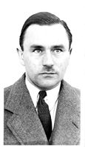
John George Haigh
Haigh, said Defense Counsel Fyfe, had been tormented for years by a recurrent dream. In it, he saw "a veritable forest of crucifixes ... the crucifixes turned into trees. Then a man appeared collecting something from the dripping trees, which seemed at first to be rain or dew. But then it became blood." The dream, said Sir David, left his client "with an overpowering desire to have blood."

The defense: insanity.
Source: http://www.time.com/time/magazine/article/0,9171,853862,00.html#ixzz1TOFi804v

John George Haigh, the ‘Acid Bath Murderer’, was hanged at Wandsworth prison on 6 Aug 1949.
“He was a lovely man” said Tetty.

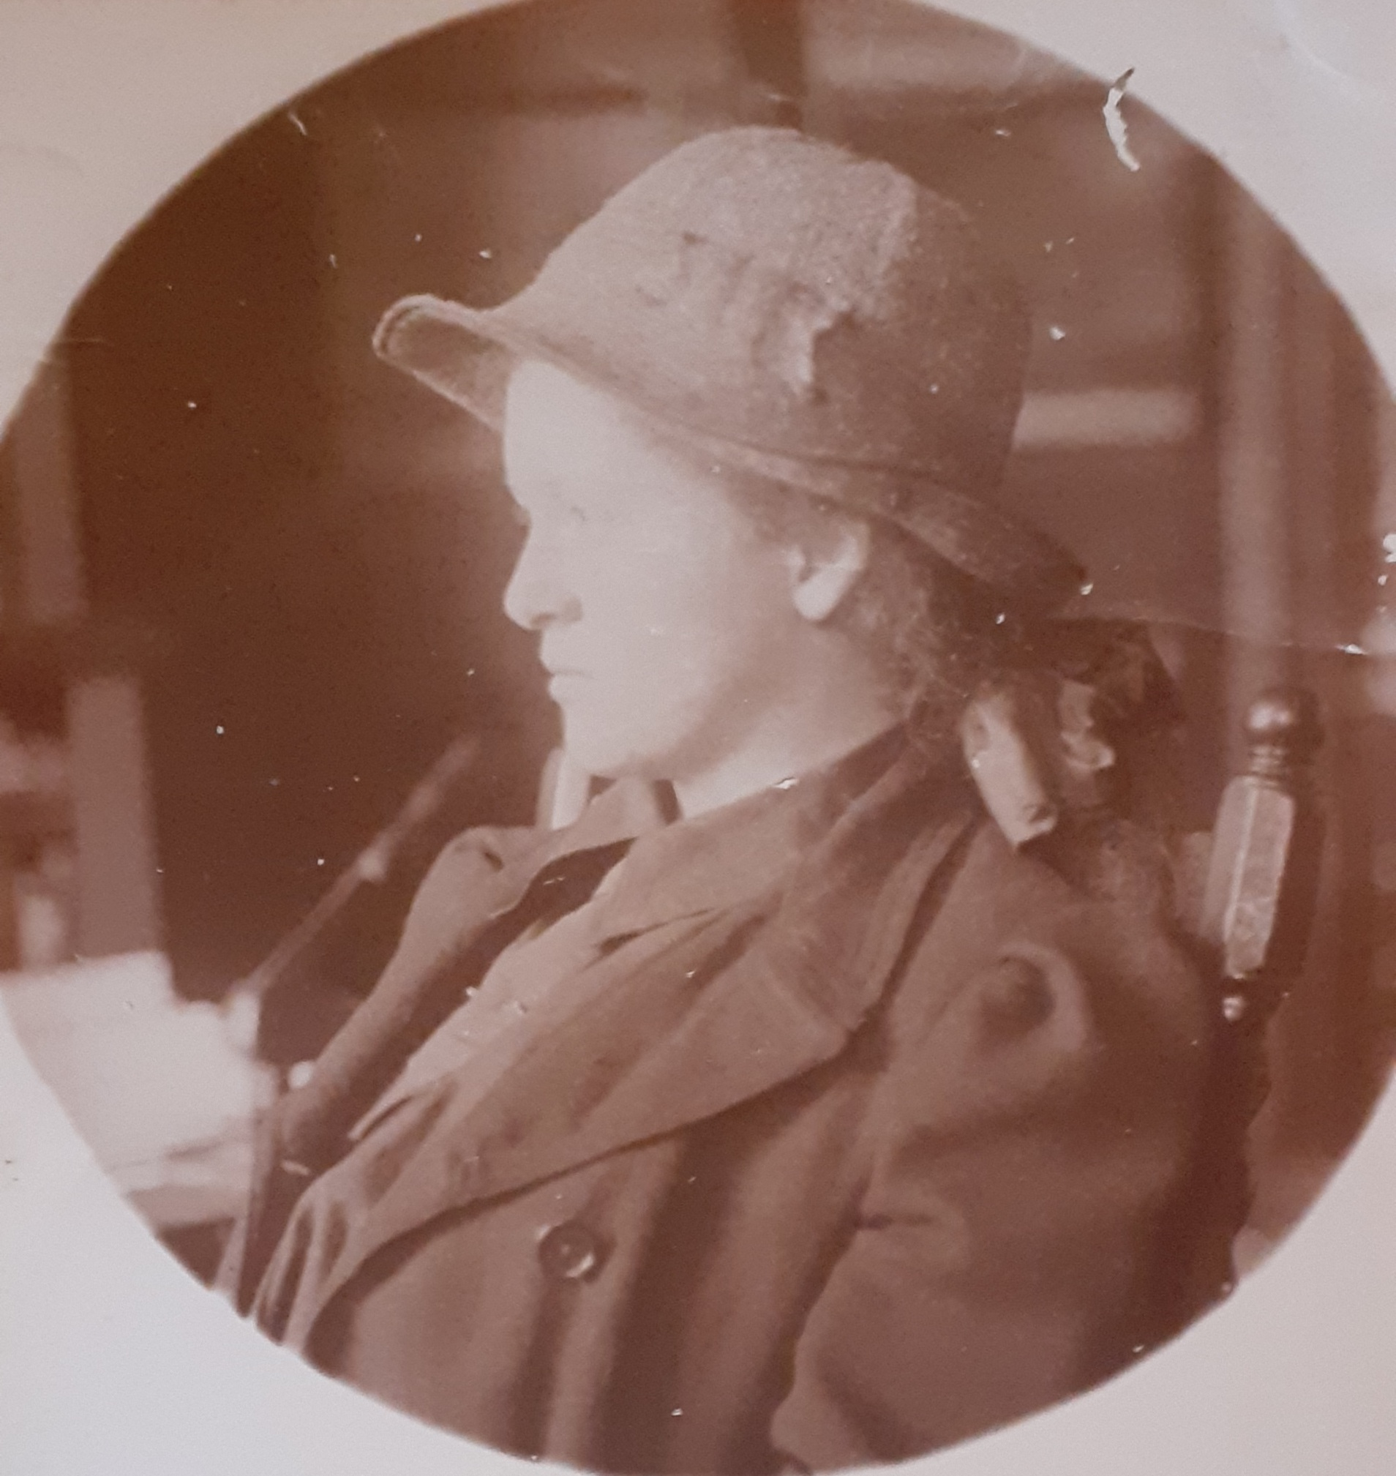

Tetty in a typical pose.

